**Knowledge Based System (KBS) for predicting the suitability of Ground Penetrating Radar**

G. Curioni, D.N. Chapman

School of Civil Engineering, University of Birmingham, Edgbaston, Birmingham, United Kingdom

E-mail: [g.curioni@bham.ac.uk](mailto:g.curioni@bham.ac.uk)

December 2015

**Installation and operational instructions**

At the current development stage the program runs with the support of a number of existing software and does not consist of a single executable file. The program was written using the R software and requires Perl (e.g. Strawberry Perl), Java (JDK) and MS Excel to be installed on the computer. The program was tested on Windows machines only, running Windows 7, Windows 8.1 and Windows 10.

Note: R is *free* and does not require a license.

**FIRST TIME USE:**

Note: this might take several minutes!

1. Copy 'R_KBS' folder in 'C:\'
2. Download and install Java Development Kit (e.g. from <http://download.cnet.com/Java-Development-Kit-64-Bit/3000-2218_4-75317068.html>). Choose the right version depending on the system in use (i.e., 32-bit, 64-bit).
3. Download and install Perl (e.g. from: <http://strawberryperl.com/>). Choose the right version depending on the system in use (i.e., 32-bit, 64-bit).
4. Download and install R for Windows (<http://cran.r-project.org/bin/windows/base/>). It is advisable to install it in a separate directory rather than in ‘Program Files’ (e.g. create a new folder called R: ‘C:\R\R-n.n.n’, where –n.n.n is the version of R being installed).
5. Right click on the R icon(s) on the desktop, select properties -> Shortcut -> Start in: 'C:\R_KBS'.

Optional: copy the R icon into the 'R_KBS' folder to be able to launch R directly from there.

1. Open R (double click on the R icon).
2. File -> Source R Code -> inst.kbs.packages.R (navigate to ‘C:\R_KBS’ if necessary).
3. Type on the R console: inst.kbs.packages()

Now the KBS is ready to use (see below). Every time a new version of R is available, *uninstall* the previous version first and repeat steps 4) to 8). It is also advisable to repeat steps 2) and 3) to use the latest versions of Java and Perl.

**EVERY OTHER TIME:**

1. Open R (double click on the R icon).
2. File -> Source R Code -> loadkbs.R
3. Type on the R console: loadkbs(); KBS()

Note: the first time these commands might take some time to process.

**KBS instructions**

1. Fill out the Excel file: *KBS.input.xlsx*

Notes: an Excel file named ‘*KBS.input.xlsx’* in the folder ‘C:\R_KBS’ must be filled out by the user. The file consists of 5 spreadsheets identifying different thematic areas. If input parameters in the sheets *geophysical* and *soil* are not known they must be left blank. The remaining sheets must be filled out by choosing one of the available classes (if insufficient information is available input ‘na’).

1. Save *KBS.input.xlsx* but **do not** change its file name.
2. Run the KBS (see above, ‘every other time’ use).
3. Results are saved in the folder ‘C:\R_KBS\kbs.output’ with name: kbs.output.'project name', in format .xlsx and .txt. If it is necessary to print the results open the .txt file and print it with PDFill or similar (choose the landscape layout). Alternatively manually select the KBS results on the R console and print directly from R (File -> Print).

**Abbreviations**

**BEC:** static (zero-frequency) bulk electrical conductivity (mS/m).

**EM :** electromagnetic.

**GPR:** Ground Penetrating Radar.

**KBS:** Knowledge Based System.

**TDR:** Time Domain Reflectometry.

**Definitions[1]**

**Sheet: *Geophysical***

**Depth (m):** the depth for which the EM properties are available (e.g. depth actually tested by an EM sensor, or depth of a target used to determine the soil permittivity by fitting a GPR hyperbola).

**Frequency (MHz):** the GPR input frequency (e.g. GPR centre frequency).

**Propagation velocity (m/s):** the signal propagation velocity in the medium under test.

**Apparent permittivity:** the permittivity value corresponding to the input frequency (e.g. the permittivity measured by GPR by fitting a hyperbola). See Table 1 for typical values.

**Real/imaginary permittivity:** the real/imaginary part of the permittivity corresponding to the input frequency.

**Real/imaginary permittivity at 100 MHz:** the real/imaginary part of the permittivity corresponding to a frequency of 100 MHz.

**Real/imaginary permittivity at 1 GHz:** the real/imaginary part of the permittivity corresponding to a frequency of 1 GHz.

**Apparent permittivity at 100 MHz:** the apparent permittivity corresponding to a frequency of 100 MHz.

**Apparent permittivity at 1 GHz:** the apparent permittivity corresponding to a frequency of 1 GHz.

**Magnitude of dispersion:** the absolute difference between the apparent permittivity at 100 MHz and at 1 GHz.

**Bulk Electrical Conductivity:** the value of static (zero-frequency) bulk electrical conductivity (mS/m). See Table 2 for typical values.

**Magnetic permeability:** the value of bulk relative magnetic permeability. Input 1 if soil is non-magnetic. Note: for GPR applications using a value of 1 is *often (not always)* a reasonable approximation.

**Attenuation coefficient:** the degree to which the signal decays with distance in dB/m. See Table 1 for typical values.

**Skin depth:** the distance (m) that a plane wave has to travel before its amplitude has reduced by factor of 1/e, or approximately 37%.

**Attenuation loss at depth: 1 m, freq: 500 MHz:** attenuation loss (dB) at a depth of 1 m for a frequency of 500 MHz.

**Attenuation loss at depth: 1 m, freq: f:** attenuation loss (dB) at a depth of 1 m for a frequency corresponding to the input frequency.

**Attenuation loss at depth: depth, freq: f:** attenuation loss (dB) at the input depth and input frequency.

**Sheet: *Soil***

**Percentage of sand:** the percentage of sand particles by weight (particle dimension between 2 mm and 0.05 mm).

**Percentage of clay:** the percentage of clay particles by weight (particle dimension < 0.002 mm).

**Percentage of gravel:** the percentage of gravel particles by weight (particle dimension > 2 mm).

**Percentage of volumetric water content:** the percentage of soil water content by volume (i.e. volume of water / volume of soil sample).

**Percentage of gravimetric water content:** the mass of water which can be removed from the soil, usually by heating at 105 °C, expressed as a percentage of the dry mass.

**Bulk density:** the mass of material (including solid particles and any contained water) per unit volume including voids (g/cm3).

**Dry density:** the mass of the dry soil contained in unit volume of undried material (g/cm3).

**Particle density:** the average mass per unit volume of the solid particles in a sample of soil, where the volume includes any sealed voids contained within the solid particles (g/cm3).

**Density factor:** coefficient ranging from 0.9 and 1.3. Values lower than 1 indicating loose soils, values greater than 1 indicating compacted soils.

**Liquid limit:** the soil gravimetric water content (%) at which a soil passes from the liquid to the plastic state.

**Plastic limit:** the soil gravimetric water content (%) at which a soil becomes too dry to be in a plastic condition.

**Plasticity index:** the difference between liquid limit and plastic limit (%).

**Linear shrinkage:** the change in length of a bar sample of soil when dried from about its liquid limit, expressed as a percentage of the initial length.

**Soil temperature:** the temperature of the soil in °C.

**Organic matter:** the percentage by dry mass of organic matter present in a soil.

**Sodium absorption ratio:** ratio indicating the concentration of sodium relative to the concentration of calcium and magnesium in the soil.

**Calcium carbonate content:** the percentage of calcium carbonate in the soil.

**Water table depth:** the depth of the water table (m).

**Sheet: *site*, *environment* and *gpr.system***

The parameters in these sheets should be self-explanatory.

**Additional definitions:**

**Soil activity:** the plasticity index divided by the percent of clay-sized particles (less than 2 μm) present in the soil.

**References:**

ATU, Assessing The Underworld: <http://assessingtheunderworld.org/> [Accessed June 2015].

BS 1377-1, 1990, *Methods of test for soils for civil engineering purposes: Part 1: General requirements and sample preparation*. London: British Standards Institution.

BS 1377-2, 1990, *Methods of test for soils for civil engineering purposes: Part 2: Classification tests*. London: British Standards Institution.

BS 1377-3, 1990, *Methods of test for soils for civil engineering purposes: Part 3: Chemical and electro-chemical tests*. London: British Standards Institution.

Cassidy N.J. (2008) “Electrical and Magnetic Properties of Rocks, Soils and Fluids” In Jol, H. (ed.) *Ground Penetrating Radar Theory and Applications - Chapter 2.* Oxford: Elsevier. pp. 41-72.

Daniels D.J. (2004) *Ground Penetrating Radar*. 2nd ed. London: The Institution of Electrical Engineers.

Davis J.L. and Annan A.P. (1989) Ground-Penetrating Radar for High-Resolution Mapping of Soil and Rock Stratigraphy. *Geophysical Prospecting*, 37: 531-551.

Dobson M.C., Ulaby F.T., Hallikainen M.T. and Elrayes M.A. (1985) Microwave dielectric behavior of wet soil – Part II. Dielectric mixing models. *IEEE Transactions on Geoscience and Remote Sensing*, 23 (1): 35-46.

Doolittle J.A. and Collins M.E. (1995) Use of soil information to determine application of ground penetrating radar. *Journal of Applied Geophysics*, 33: 101-108.

Doolittle J.A., Minzenmayer F.E., Waltman S.W., Benham E.C., Tuttle J.W. and Peaslee S.D. (2007) Ground-penetrating radar soil suitability map of the conterminous United States. *Geoderma*, 141: 416-421.

Doolittle J.A., Dobos R., Peaslee S.D., Waltman S.W., Benham E.C. and Tuttle J.W. (2010) Revised Ground-Penetrating Radar Soil Suitability Maps. *Journal of Environmental and Engineering Geophysics*, 15 (3): 111-118.

Matthews S.L. (1998) *Subsurface radar as an investigative technique*, Building Research Establishment Report BR 340, CRC, Garston, Watford.

Mironov V.L., Kosolapova L.G. and Fomin S.V. (2009) Physically and Mineralogically Based Spectroscopic Dielectric Model for Moist Soils. *IEEE Transactions on Geoscience and Remote Sensing*, 47 (7): 2059-2070.

MTU, Mapping The Underworld: <http://www.mappingtheunderworld.ac.uk/> [Accessed June 2015].

Peplinski N.R., Ulaby F.T. and Dobson M.C. (1995a) Dielectric Properties of Soils in the 0.3-1.3 GHz Range. *IEEE Transactions on Geoscience and Remote Sensing*, 33 (3): 803-807.

Peplinski N.R., Ulaby F.T. and Dobson M.C. (1995b) Corrections to “Dielectric Properties of Soils in the 0.3-1.3 GHz Range”. *IEEE Transactions on Geoscience and Remote Sensing*, 33 (6): 1340.

Robinson D.A., Jones S.B., Wraith J.M., Or D. and Friedman S.P. (2003a) A Review of Advances in Dielectric and Electrical Conductivity Measurement in Soils Using Time Domain Reflectometry. *Vadose Zone Journal*, 2 (4): 444-475.

Saxton K.E. and Rawls W.J. (2006) Soil Water Characteristic Estimates by Texture and Organic Matter for Hydrologic Solutions. *Soil Science Society American Journal*, 70: 1569-1578.

Saxton K.E. and Willey P.H. (2006) “The SPAW model for agricultural field and pond hydrologic simulation” In Singh V.P. and Frevert D.K. (ed.) *Watershed models.* Boca Raton, Fl.: CRC Press. pp. 401–435.

Thomas A.M., Chapman D.N., Rogers C.D.F. and Metje N. (2010a) Electromagnetic properties of the ground: Part I – Fine-grained soils at the Liquid Limit. *Tunnelling and Underground Space Technology*, 25: 714-722.

Topp G.C., Davis J.L. and Annan A.P. (1980) Electromagnetic Determination of Soil-Water Content: Measurements in Coaxial Transmission Lines. *Water Resources Research*, 16 (3): 574-582.

Topp G.C., Zegelin S. and White I. (2000) Impacts of the Real and Imaginary Components of Relative Permittivity on Time Domain Reflectometry Measurements in Soils. *Soil Science Society of America Journal*, 64: 1244-1252.

Venables W.N., Smith D.M. and the R Development Core Team (2012) *An Introduction to R – Notes on R: A Programming Environment for Data Analysis and Graphics* – Version 2.15.1.

Table 1 – Typical attenuation and dielectric permittivity of various materials measured at 100 MHz (from Daniels, 2004).

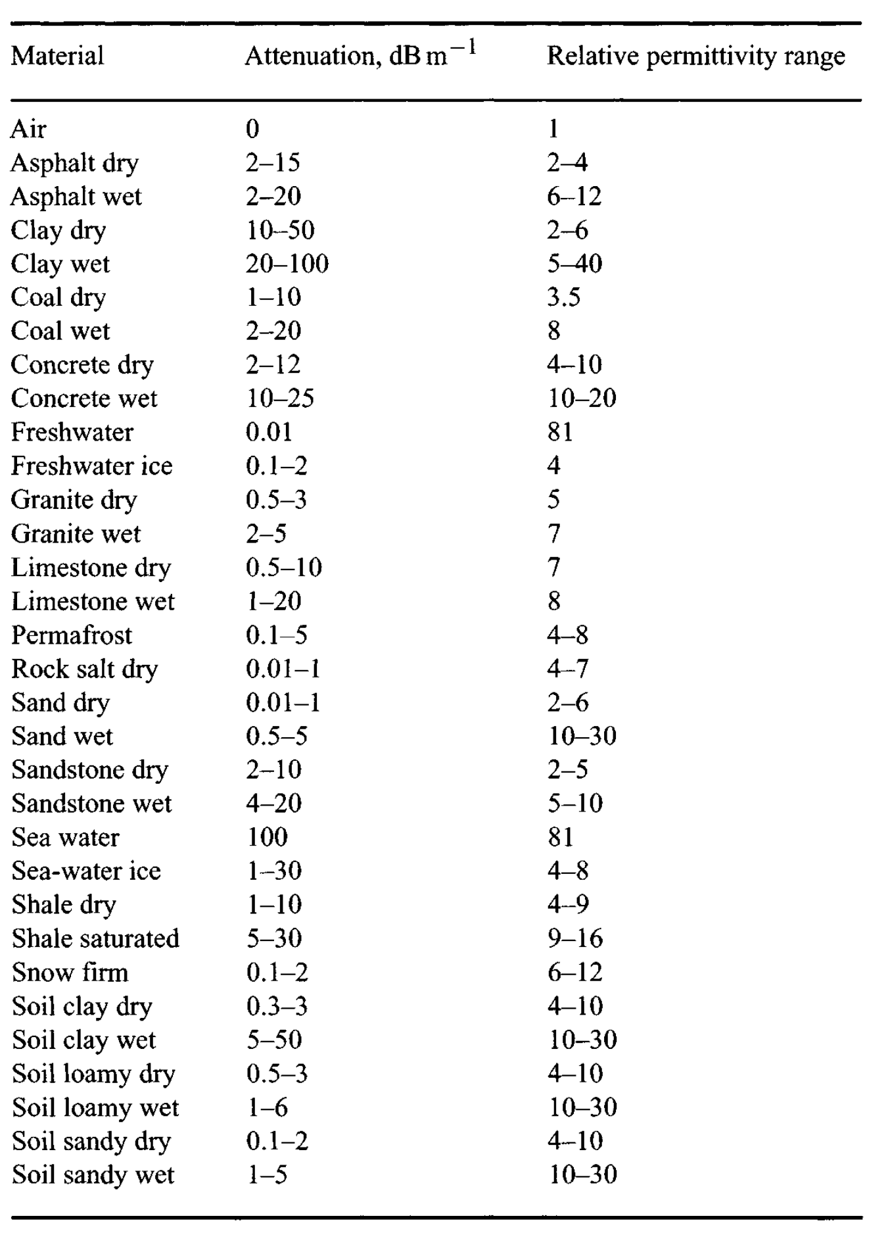

Table 2 – Typical range of bulk electrical conductivity of various materials measured at 100 MHz (from Daniels, 2004).

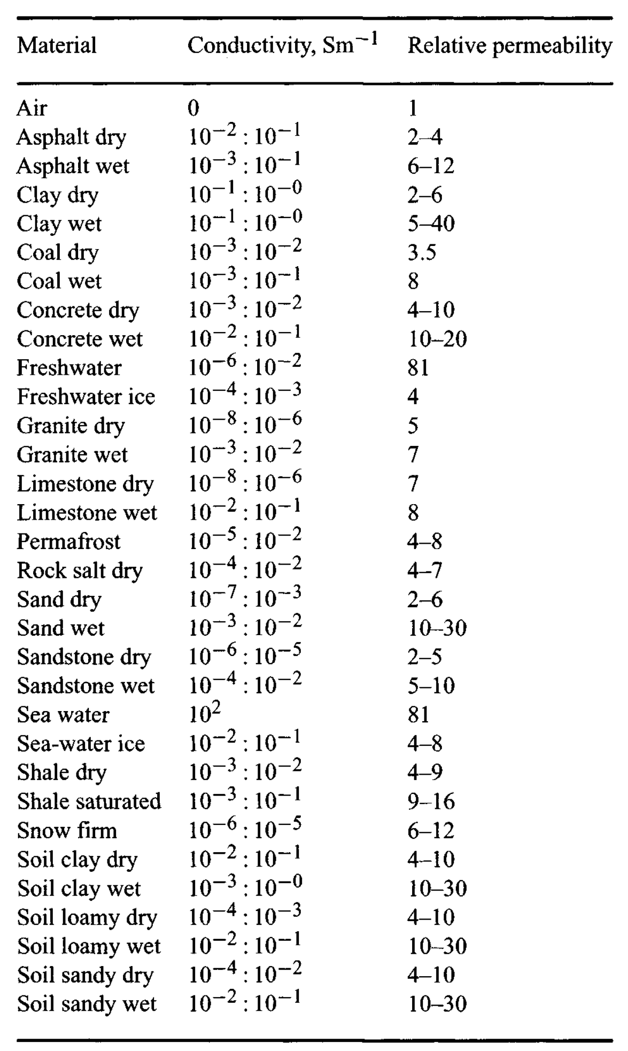

1. Definitions are not to be considered very rigorous but serve to clarify the meaning of the parameters used. Whenever possible, the definitions were taken from the British Standards (BS 1377).